Муниципальное бюджетное общеобразовательное учреждение средняя общеобразовательная школа с.Ярославка муниципального района Дуванский район Республики Башкортостана

Обобщающий урок
по английскому языку
«Conversation about food. Shopping»
8 класс

Рыжая Наталья Васильевна, учитель английского языка, МБОУ СОШ с.Ярославка Республика Башкортостан

с.Ярославка 2014г
Обобщающий урок английского языка в 8 классе
«Conversation about food. Shopping»
Цели: 1.Совершенствование умений и навыков практического владения английским языком по видам речевой деятельности: аудированию, говорению, чтению, письму.
- Развитие творческих способностей школьников, умение анализировать.
- Повышение интереса к культуре, традициям других стран; повышение интереса к изучению английского языка.
Задача: контроль знаний по теме «Shopping. Food»
Оборудование: карточки с заданиями, магнитофон, ингредиенты для салата.
Ход урока
I. Organization Period
Teacher: Good morning, children! Sit down, please. Г m very glad to see you. It's time to begin our lesson.
Фон зарядка: Let's train our tonge.
Bessie Botter bought A bit of butter But the butter that She bought was bitter So, she bought a bit of Better butter.
II. Introduction of the Theme
Teacher: Our topic today is "Conversation about food. Shopping". Dear students, I nope - that you are fine today. On your desks you can see pictures of different moods. You can choose one which really shows how you are feeling at the moment. You can put a tick in front of it. (Приложение 1)
Today we are going to speak, listen to gialoges, read, learn new words, write about shopping for food: Today we'll make some stops: They are: 1. Advanced vocabulary. 2. Shopping for food. 3. Let's cook! 4. What do I eat to be healthy?
You will also evaluate your work yourselves using the mountain of success. On the tables you can see the Mountain of Success and our lesson evaluation. (Приложение 2) Your aim is to reach the top of the mountain by the end of the lesson. And now let's begin our lesson.
1. Teacher: - Our first stop is "Advanced vocabulary". Ex.1. Listen to how to pronounce these words about food. Learn how to write these words. On your desks we can see sheets with these worlds.
salt | СОЛЬ | pineapple | ананас
pepper | перец | orange- | апельсин
spices | специи,пряности | grapes | виноград
ginger | имбирь | peach | персик
vanilla | ваниль | apricot | абрикос
cinnamon | корица | grapefruit | грейпфрут
marjoram | майоран | meat | мясо
vinegar | уксус | chicken | цыпленок
flour | мука | pork | свинина
vegetables | овощи | beer' | говядина
garlic- | чеснок | mutton | баранина
beans | фасоль | lamb | молодая баранина
peas | горошек | sausage | колбаса
carrot | морковь | ham | шинка
green pepper | зеленый перец | Hsh | рыба
cucumber | огурец | cod | треска
cauliflower | цветная капуста | salmon | лосось
broccoli | капуста брокколи | yogurt | Йогурт
cabbage | капуста | cottage cheese | I ворог
radish | редиска | cream | сметана
horseradish | хрен | mineral water | минеральная вода
fruit | фрукты | fizzy water | газированная вода
melon | ДЫНЯ | nuts | орехи
strawberry | клубника | crisps | хрустящие хлебцы
banana | банан | sweets | слалос п 1
Teacher: - Turn over the sheets and find Ex. 2.
Teacher: - Look at the picture and say what you can see in it.

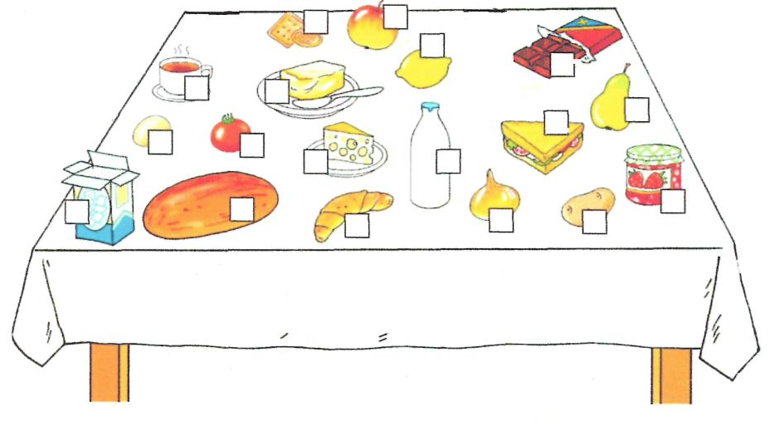
2. Teacher: Our next stop is "Shopping for food".
- Listen to the dialoge. Read it. Dramatize the dialoge. Look at the pictures and say what Mary is buying.
Shop assistant: "Good morning, madam. Can I help you?" Mary: "I'd like three kilos of potatoes and two kilos of tomatoes." Shop assistant: "OK. Here you are. Anything else, madam?" Mary: "Yes. A carton of orange juice, please. And three bars of chocolate." Shop assistant: "Is that all?"
Mary: "No. I'd like a piece of cheese as well. About 250 grams." Shop assistant: "OK, 250 grams." Mary: "That's all, thank you."
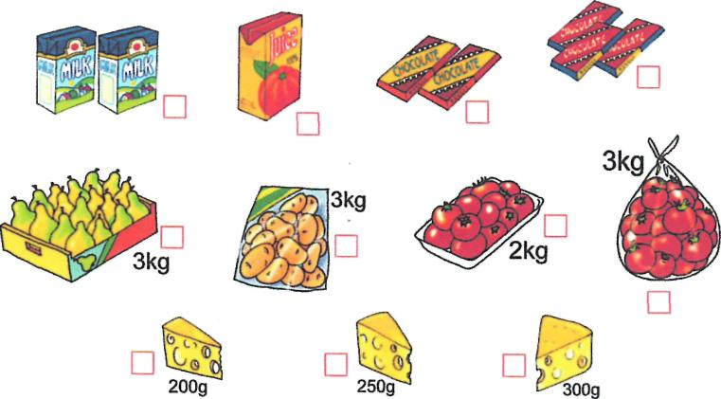
Teacher: - Let's train these useful phrases. Read and then name them.

USEFUL PHRASES П0.1ЕЗНЫЕ ВЫРАЖЕНИЯ
-Shop assistant / ПряЪжц | Customer / Клиент
Can ! help you? Чем могу помочь? | I'd like... Пожалуйста,... /я хотел бы...
Anything else? Еще что-нибудь? | I'll take it. Я возьму...
Is that all? Это все? | How much is...? Сколько стоит...?
Here you arc. Дайте, пожалуйста ... (то, что нужно клиенту) | Give me..., please. Дайте мне, пожалуйста...
Of course. Конечно. | Can 1 pay by credit card?  Могу ли я заплатить кредитной карточкой ?
Teacher: - Say it right. Make up as many true word combinations as you can.
- bottle a. jam
- lithe b. oil
- kilo с chocolate
- bar d. milk
3

- cup
- loaf
- piece
- pack
- can lO.jar
e. lemonade
f. sugar
g. butter
h. cheese
i. bread
j.coffe.

Teacher: - Work in pairs. Make up your own dialoge "At the shop". Pictures help you. (Картинки по теме в магазине)

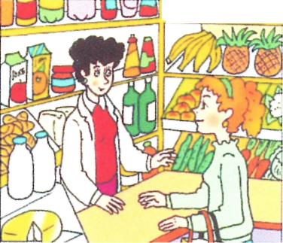
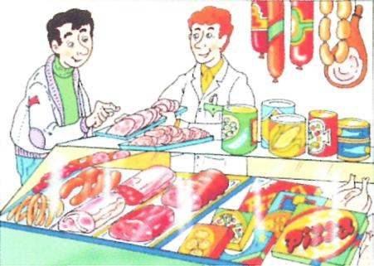

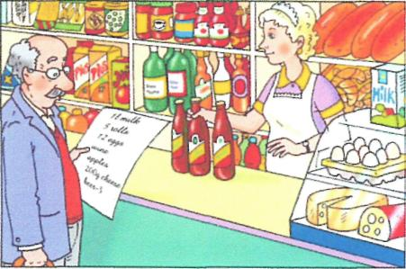
3. Teacher: Our next stop is - Let's cook! Read an article about the Toscany family. Wbat is it about? Read a recipe of a tipical English dish "Shepherds Pie"

When you want to prepare a typical British Shepherd's Pie, you need: 500g minced lamb, 1 onion, lOOg mushrooms, 2 carrots, 30g flour, 300ml lamb stock, 800g potatoes, 30g butter, 50ml milk, 70g cheese, salt and pepper. You probably do not have all these ingredients at home. You have to go shopping and buy them.
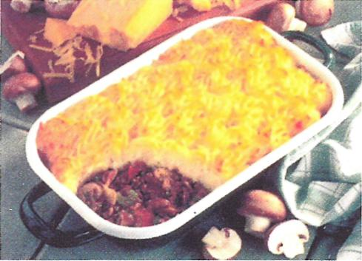

4

Shopping list
- 2 packs of spaghetti
- 100 g cheese
- 200g mushrooms
- 250g bacon -olives
1-1 bottle of ketchup

Teacher: - When you are hungry and you do not want to cook a difficult meal, you can prepare a very simple salad. Learn how to pronounce and write these words.

Add | Добавлять | Grate | Тереть (на терке)
Bowl | Миска, салатница | Mix | Мешать
Cold | Холодный | Serve | Подавать
Dice | Нарезать кубиками | Slice | Нарезать ломтиками
Make up recipe of "Vegetables salad'
Ingredients: 1 cucumber
3 tomatoes
2 carrots
2 red peppers olive oil salt.
Method: 1. Slice tomatoes, dice peppers and cucumber and grate carrots. Put them all in a bowl. 2. Add salt and olive oil. 3. Mix them all together. 4. Serve cold.
4. Teacher: Our fourth stop is "What do I eat to be healthy?"
Nowadays people want to be strong and healthy. What about you? If you want to keep fit remember the rules:
Good Rules to Remember
- Get up early and go to bed early to keep fit.
- Take u cool / cold shower to keep fit.
- Take regular exercises to keep fit.
- Eeat healthy food to keep fit.
- Never smoke to keep fit.
- Clean your teeth every morning and every evening to keep fit.
- Wash your hands before you eat to keep fit.
5
Dor 't forget
Too little food makes you thin Too much food makes you fat The wrong food makes you ill The right food keeps you well
Teacher: - Read the text about Isabelle, and answer to Isabelle's guestions and say why the text is called "What do I eat to be heathy?"
WHAT DO I EAT TO BE HEALTHY?
Hello, my name is Isabelle. I work in an office. I love my job, but I sit at my desk all the time. I usually run in the park after work and I eat healthy food to be fit.
I prefer fruit and vegetables. I like bananas, oranges, melons, apples, cucumbers, tomatoes and lettuce.
For breakfast I usually have cereal and milk. I never eat bread, salami or eggs! When I come to work, I make a cup of coffee - without sugar, of course. My lunchbreak is very short. I just eat a chicken sandwich with lettuce - and no mayonnaise.
I try to have a hot meal for dinner every day. I usually eat chicken or fish with potatoes or rice. And a lot of vegetables! Do you want to know my secret? I love chocolate!
Milk chocolate is my favourite. I eat it sometimes and then run for a longer time in the park!
Teacher: - Could you answer the following guestions:
- What are Isabellas favourite fruits ?
- And favourite vegetables ?
- What is her favourite drink in the morning?
- What sandwich does she eat for lunch?
E) Does she eat anything unhealthy?
F) What is her usual dinner?
III. Conclusion
Teacher: Take your pictures of different moods more and choose one which shows your mood at the moment. Is it different? Can you explain why? So our lesson is over. Thank you for your work.
You are hard - working children.
Your homework will be the following: Describe your last visit to the sweet shop.
6
Приложение 1

Exhausted - уставший, изможденный
Ecstatic - восторженный
Suspicious - подозрительный
Hysterical - истеричный
Sad - печальный, унылый
Embarrassed - смущенный
Mischievous - вредный
Frightened - испуганный
Ashamed - пристыженный
Smug - самодовольный
Overwhelmed - ошеломленный
Lonely - одинокий
Jealous - ревнивый
Surprised - удивленный
Shy - в стеснении, в нерешительности
Confused - сконфуженный Guilty -виноватый
Angry - злой
Frustrated - расстроенный Confident -самоуверенный Happy - счастливый Disgusted - в омерзении Enraged - в бешенстве Cautious - осторожный Depressed - депрессивный Hopeful - обнадеженный Bored - скучный

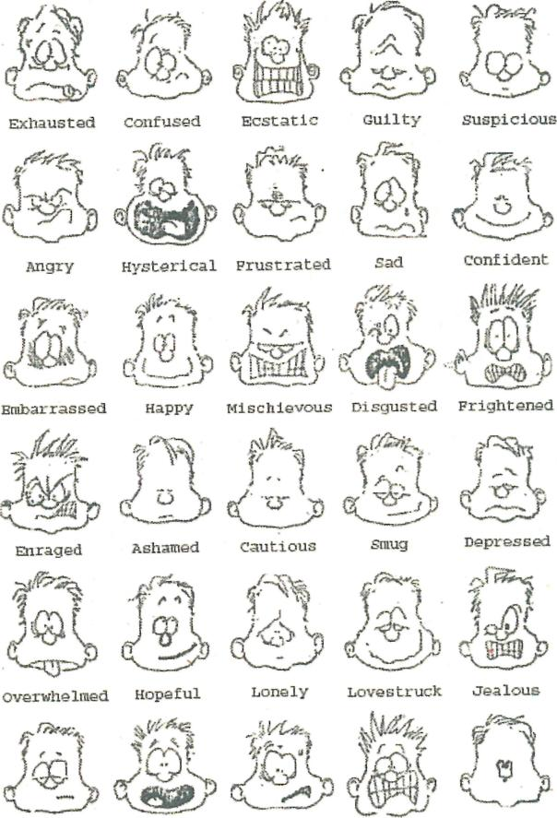

Bored

surprised
Anxious
Shocked
shy

Mountain of Success

What do I eat to be healthy?
Let's cook!
Shopping for food
Advanced vocabu lary
Lesson Evaluation Sheet

 | Your answer | Right answer | Mountain of success
Advanced vocabu lary
Shopping for food
Let's cook!
What do I eat to be healthy?

